International Rhythmic Gymnastics Tournament

May 9-10.2026
Paralimni Famagusta Cyprus

Our location is near the crystal blue east Mediterranean Sea with the most beautiful, famous and award winning beaches of Protaras, Agia Napa, Kapparis, Famagusta Cyprus. This is a unique opportunity to combine sport, national hospitality and relaxation on the beach.

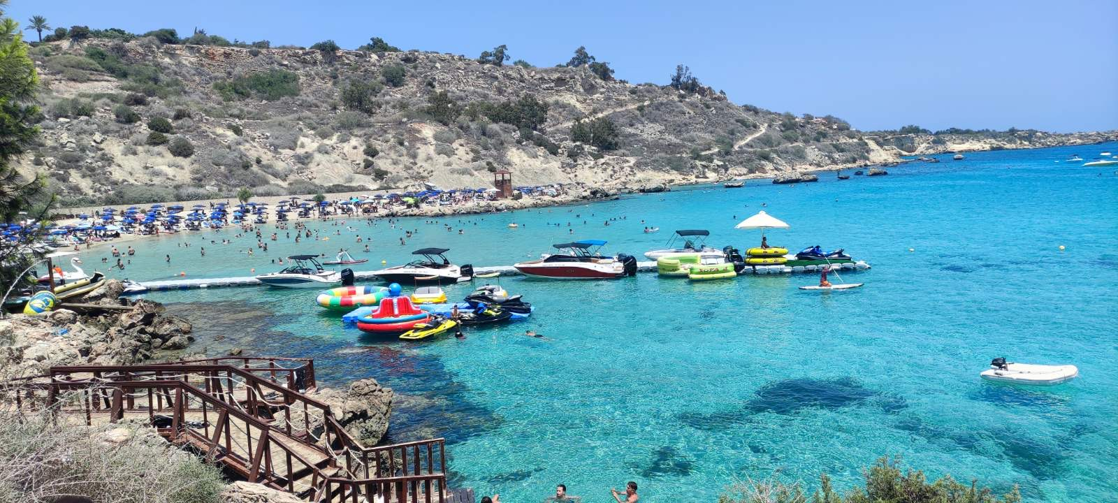

HOST CLUB | Name: RGA FAMAGUSTA CYPRUS    Contact person: Liubov Zakharova  Phone: +357 99725568 & WhatsApp  e-mail: liubasha7@gmail.com
VENUE | Name: New Indoor Stadium < PALATAKI > Paralimni  Address: 2XXV+3FV, Unnamed Road, Παραλίμνι  https://share.google/gegjApVkcBlLtWAoJ  Ceiling height in the Sport Hall is 11 m, we do not recommend you to use ribbons  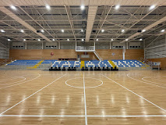
DATES | Friday 8.05.26 Arrival and accreditation of delegations  Saturday 9.05.26 Judging meeting, 1st day of competitions  Sunday 10.05.26 Judging meeting, 2nd day of competitions  Monday 11.05.26 Departure of delegations  Please let us know if you plan to arrive earlier or depart later than  these dates. We will arrange extra training for you.
ENTRY FEES | Individual:  3 programs €70  2 programs €50  1 programs €30  Unlimited number of gymnasts, coaches, judges, accompanying  persons  Each delegation has to bring as minimum 1 judge or pay fees €100
REGISTRATION | Application form on the web: https://gm-events.com
CATEGORIES | BABIES 2020-2019 W/A  A CHILDREN 2018-2017 W/H+1 App by choice or 2 App. By choice  B CHLDREN 2018-2017 W/H+1 App.by choice or 2 App. By choice  A HOPES 2016-2015 W/H+2 App by choice or 3 App. By choice  B HOPES 2016-2015 W/H+1 App by choice or 2 App. By choice  A PRE-JUNIORS 2014-2013 3 App by choice  B PRE-JUNIORS 2014-2013 2 App. by choice  A JUNIORS 2012-2011 3 App by choice  B JUNIORS 2012-2013 2 App. by choice  A SENIORS 2010 and alder 3 App. By choice  B SENIORS 2010 and older 2 App. by choice  W/A min 2S, min 6DB, max 4R with min 3 rotations (each R value 0.3 regardless of the criteria)  Apparatus complies with FIG rules 2025-2028
AWARDS | Awarding: for 1st 2nd 3rd places for all around with 2 App.  and with 3 App.  Awarding for 1st – 8th in each App. in each category  Gifts and participant’s medals for all the gymnasts
DEADLINES | Nominative registration: 25.04.2026  Music uploads: 20.04.2026  Gala deadline 20.04.2026  Each file must be in mp3 format & have the athlete’s name,  age, level, App., country (EN): IVANONA Maria 2016 A Hoop CYP  Every team must have a USB device with music as well.
ACCOMODATION | Malama beach holiday village 4*  2 adults (12+) with breakfast €118, €138 per night  2 adults (12+) +1 child (2-12) with breakfast €118, €138 per night  2 adults (12+) +2 children (2-12) with breakfast €142, €162 per night  3 adults (12+) +1child (2-12) with breakfast €155,1 €198 per night  4 adults (12+) with breakfast €191, €211per night  The price depends on the location within the territory and view,  booking for 5 nights minimum.  Amore Hotel Apartments 3*  1bedroom apartment, no breakfast, €50 per night  Maximum occupancy is 3 persons  2bedroom apartment, no breakfast, €120 per night  Maximum occupancy is 5 persons  All the rooms are equipped with a kitchen,  booking for 3 nights minimum.  More information about more Hotels and Hotel-apartments  will be later
VISA | Please check if your delegation needs a visa.  We will prepare personal invitation for the Embassy
MEALS  TRANSFER  SIGHTSEEING  PAYMENT  CANCELLATION  INSURANCE  MEDICAL SERVICE | There is a snacks bar in the Sport Hall  During the competition lunch and snacks will be provided to all judges at the Sport Hall for free  FROM &TO Larnaca airport (54 km)  Information for transfer will be later  We can organize tours with a visit to:  - Famous Christians Orthodox churches  - The mountains with a visit to Kikos Monastery (XI century)  - The village of craftsmen in Lefkara in the mountains  - The national park with pink flamingos  - The best beaches of Famagusta region.  The prices will be sent up to your request.  The bank account details will be sent with an invoice  After 25.04.2026 any cancellation of hotels and entry fees  are non-refundable  Every delegation is responsible for covering expenses of accidents  or illness or other of their athletes or members of a team.  The organizing committee will provide first aid medical services  during the competition.

